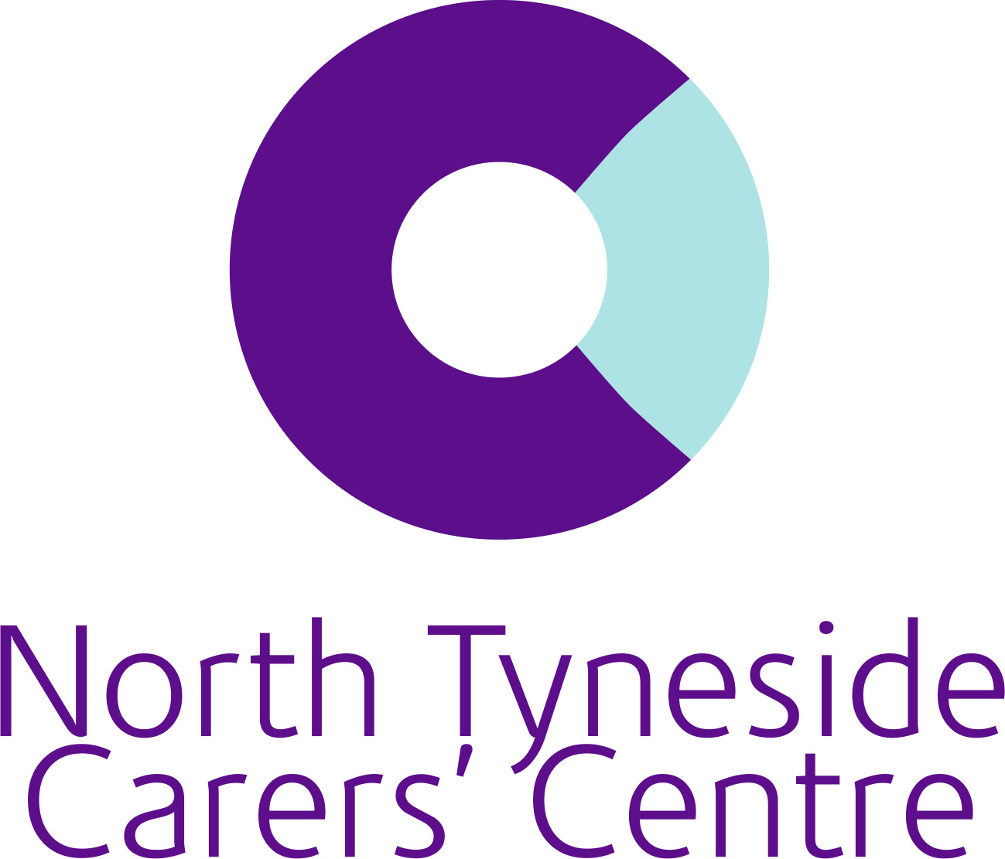

**April– Young Carers’ Forum**

Date: 28th April 2025

Attendees: 4 young carers

**Discussion topic:**

* Carers Week 2025
* Breaks and Activities service



Carers Week 2025 will commence on 9th June 2025.

This year the theme is '[Caring About Equality](https://www.carersweek.org/about-carers-week/carers-week-theme-caring-about-equality/)' highlighting the inequalities faced by unpaid carers, including a greater risk of poverty, social isolation, poor mental and physical health. Far too often, all-age carers miss out on opportunities in their education, careers, or personal lives, just because of their caring role.

The group supported our social media campaign by creating word art



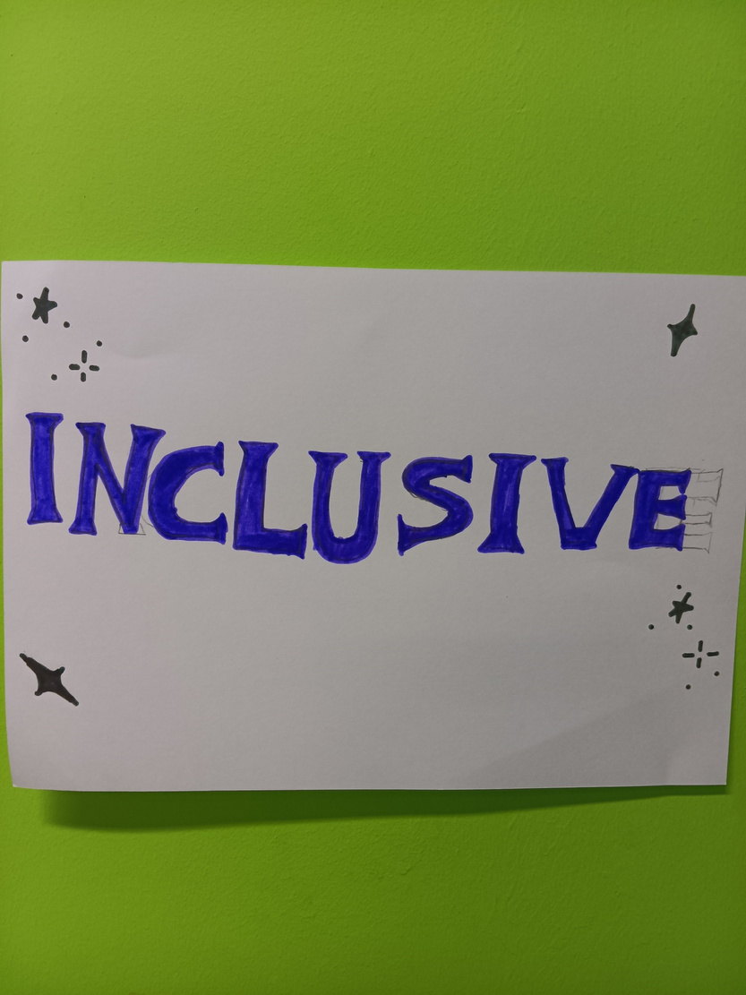

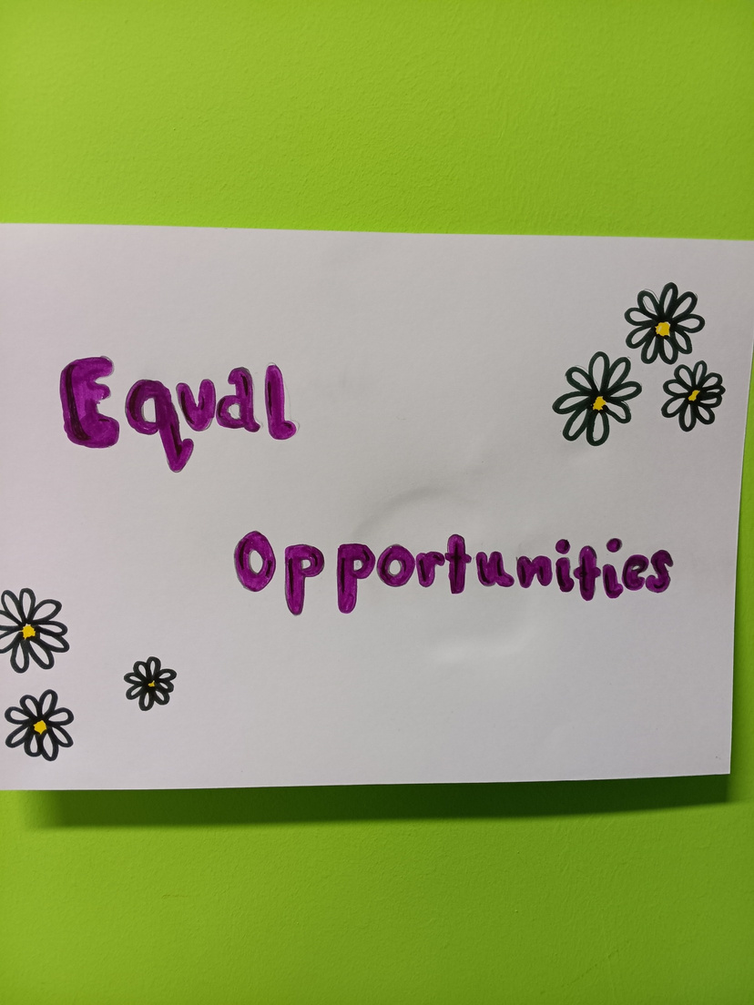

Breaks and Activities: The group thought of activities which are free of charge in our local area. They also thought about healthy snacks and prizes for games which will be beneficial to how we support carers and shape our service going forward.

We discussed the importance of healthy eating. North Tyneside Carers Centre is committed to promoting young people to stay active and choose healthy food options, which is why we need input and ideas for carers on what snacks we provide in sessions, but be mindful of the nutritional value.

Kate shared with the group that, as we are a charity, we rely on funding to provide all activities, and we always need to ensure we provide the best service at a low cost.

Activity ideas:

Beach day

Park days

Swimming

Trips to animal centres and petting zoos

Ease Into activities

Food Ideas:

Wraps

Mixed fruits and berries

Cheese

Meats

Prizes:

Trophies

Certificates

Fidget Toys

Colouring books and pens

Due to staff absence, the next monthly meeting will be shared once confirmed. Thank you to everyone for your support in attending and for inputting your ideas.

If anyone is age 16+ and wishes to support our service through volunteering, please contact us on 0191249 6480